MIKROTIK FIREWALL CONFIGURATION

TARGET:
1) First make all the ip assigning make the routing and NAT and connect to the world (pre work)
2) connect all the 4 pc 2 are linux and 2 are VPCS
3) ip are
1→192.168.88.10
2→192.168.88.11
3→192.168.88.12
4→192.168.88.13
create a basic firewall rule to access onle first and second can access to the internet other cant connect even they are connected to the router.

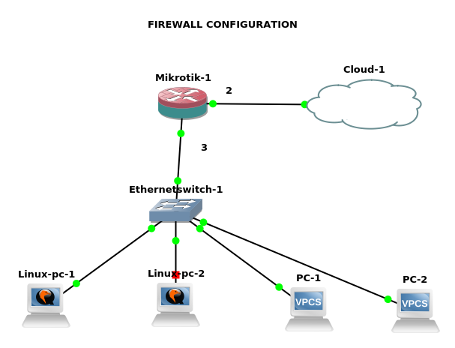

Router configuration:
[admin@MikroTik] > ip address add address=10.42.0.99/24 interface=ether2
[admin@MikroTik] > ip address add address=192.168.88.1/24 interface=ether3
[admin@MikroTik] > ip route add gateway=10.42.0.1
[admin@MikroTik] > ip dns set servers=8.8.8.8
[admin@MikroTik] > ip firewall address-list add list=Allowed address=192.168.88.10
[admin@MikroTik] > ip firewall address-list add list=Allowed address=192.168.88.11
[admin@MikroTik] /ip firewall nat>
[admin@MikroTik] /ip firewall nat> add chain=srcnat src-address-list=Allowed action=masquerade

VPCS with ip address 192.168.88.10/24

PC-2> ip 192.168.88.10/24 192.168.88.1
Checking for duplicate address...
PC1 : 192.168.88.10 255.255.255.0 gateway 192.168.88.1

PC-2> ip dns 8.8.8.8

PC-2> ping 8.8.8.8

84 bytes from 8.8.8.8 icmp_seq=1 ttl=116 time=143.448 ms
84 bytes from 8.8.8.8 icmp_seq=2 ttl=116 time=96.479 ms

vpcs with 192.168.88.12/24 ip:

PC-1> ip 192.168.88.12/24 192.168.88.1
Checking for duplicate address...
PC1 : 192.168.88.12 255.255.255.0 gateway 192.168.88.1
PC-1> ip dns 8.8.8.8
PC-1> ping 8.8.8.8

8.8.8.8 icmp_seq=1 timeout
8.8.8.8 icmp_seq=2 timeout
8.8.8.8 icmp_seq=3 timeout
8.8.8.8 icmp_seq=4 timeout

Adding 192.168.88.11/24 ip in a linux pc
gns3@box:~$ sudo ip addr add 192.168.88.11/24 dev eth0
gns3@box:~$ sudo ip addr add 192.168.88.11/24 dev eth0
gns3@box:~$ sudo route add default gw 192.168.88.1
gns3@box:~$ ping 8.8.8.8
PING 8.8.8.8 (8.8.8.8): 56 data bytes
64 bytes from 8.8.8.8: seq=0 ttl=116 time=57.029 ms
64 bytes from 8.8.8.8: seq=1 ttl=116 time=55.171 ms
64 bytes from 8.8.8.8: seq=2 ttl=116 time=57.991 ms
^C
--- 8.8.8.8 ping statistics ---
3 packets transmitted, 3 packets received, 0% packet loss
round-trip min/avg/max = 55.171/56.730/57.991 ms

